Assignment - 1

OPERATING SYSTEM

TOPIC: BASIC UNIX COMMANDS & FILE SYSTEM COMMANDS

____________________________________________________________________________

1. Display the date using the “**date**” command.



1. Check who are the users logged in using the “**who**” command.
2. 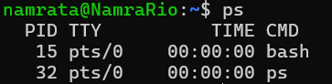Check the running processes using the “**ps**” command.
3. 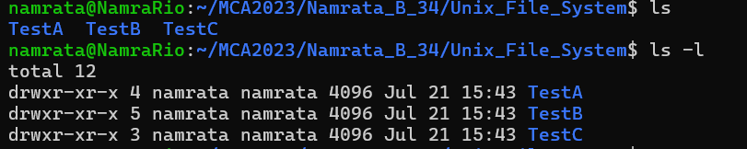List the files with “**ls**” command with and without **-l** option.
4. 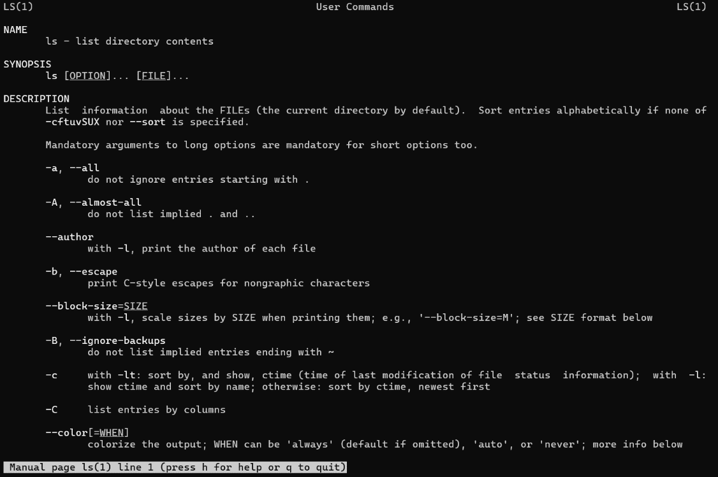Check the *manual of* **ls** command.
5. Show the commands used to display (i) filenames (ii) processes (iii)users.
6. filenames : ls
7. 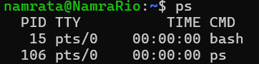processes : ps
8. users: who
9. Check and state the difference between man and whatis command by checking **man cp** & **whatis cp**.

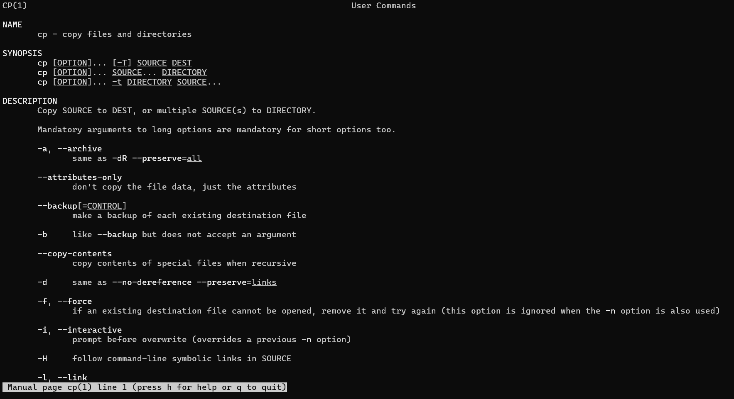 man cp:

whatis cp:

difference between man and whatis:

| **Feature** | **man Command** | **whatis Command** |
| --- | --- | --- |
| **Purpose** | Displays the manual page for a command, providing detailed information including usage, options, and examples. | Provides a brief one-line description of a command. |
| **Output Detail** | Extensive and detailed information, often several pages long. | Concise and brief, usually a single line. |
| **Depth of Information** | Comprehensive and in-depth, including sections like NAME, SYNOPSIS, DESCRIPTION, OPTIONS, EXAMPLES, etc. | Summarized and to the point. |

1. What is the primary difference between **printf** and **echo** command. Check and print.

Printf:

Echo:

Difference between printf and echo:

| **Feature** | **printf Command** | **echo Command** |
| --- | --- | --- |
| **Purpose** | Formats and prints data according to specified format. | Prints arguments to the standard output. |
| **Formatting** | Offers extensive formatting options similar to the C printf function (e.g., format specifiers like %d, %s, %f). | Limited or no formatting capabilities; simply outputs text. |

1. 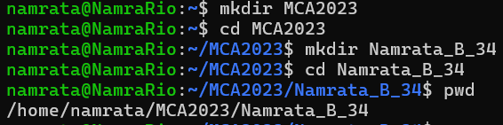In the home directory, create a directory *MCA2022*. Inside the *MCA2022,* create another directory *<FistName_Section_ClassRoll>* and get into the directory [**~ /MCA2022/Ankur_A_00$**].
2. Go to the subdirectory and create another subdirectory “**Unix_File_System**” within it.
3. Create the subdirectories TestA, TestB, TestC and corresponding sub-subdirectories TestA-1, TestA-2, TestB-1, TestB-2, TestB-3, TestC-1, TestB-2-i in a single command.
4. Show the absolute path of TestB-2-i.